**[OUTPUT] C++ Singly Linked List**

1. **Main Menu**

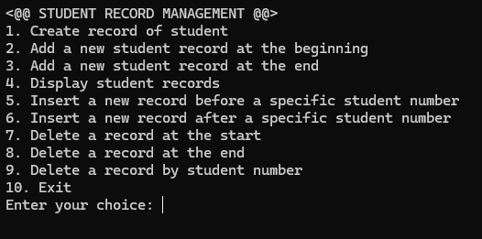

1. **Create record of student**

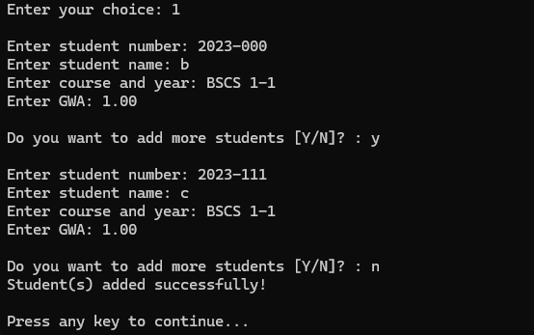

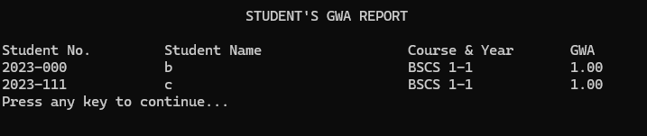

1. **Add a new student record at the beginning**

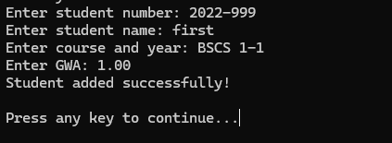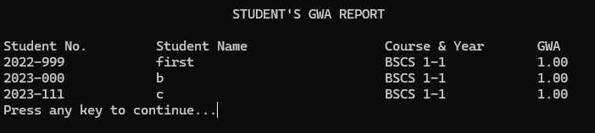

1. **Add a new student record at the end**

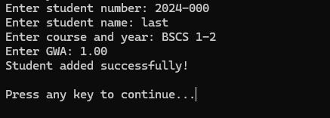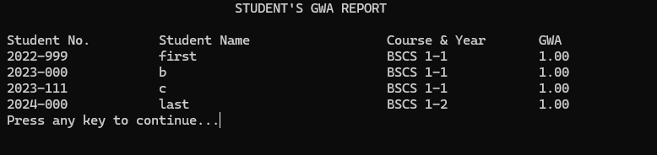

1. **Insert a new record before a specific student number**

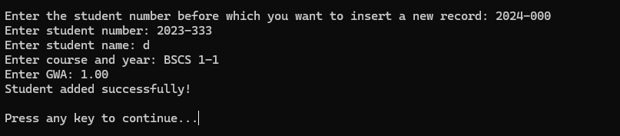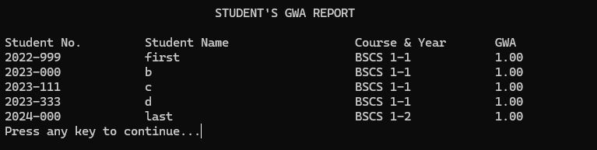

*(if not found)*

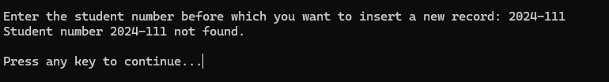

1. **Insert a new record after a specific student number**

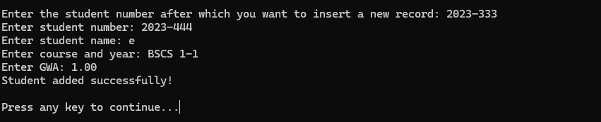

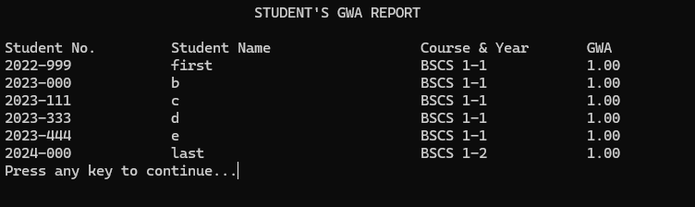

*(if not found)*

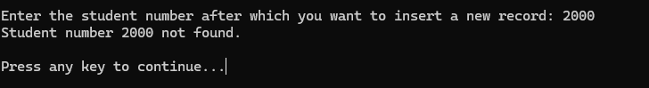

1. **Delete a record at the start**

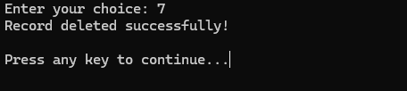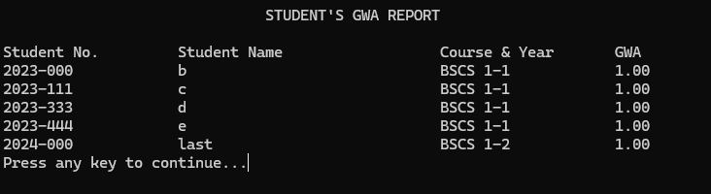

1. **Delete a record at the end**

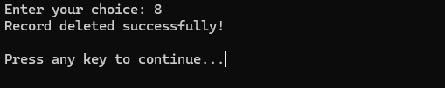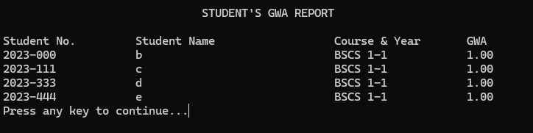

1. **Delete a record by student number**

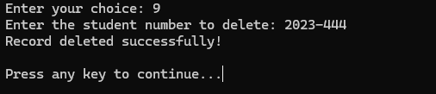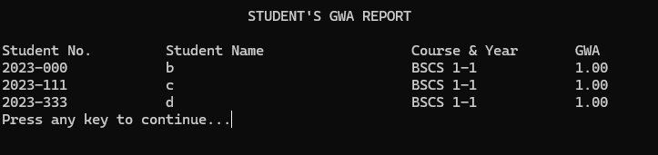

*(if not found)*

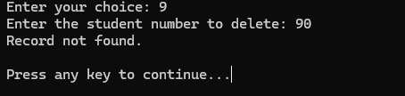

1. **Exit**

